**Ayesha Zubair**

**52916**

**Lab 11**

**Task 1**

**Set memory location 009 to -3. Increment by 3 and make it 0. Perform ISZ operation. Show the results.**

INP

ISZ 009

OUT

HALT

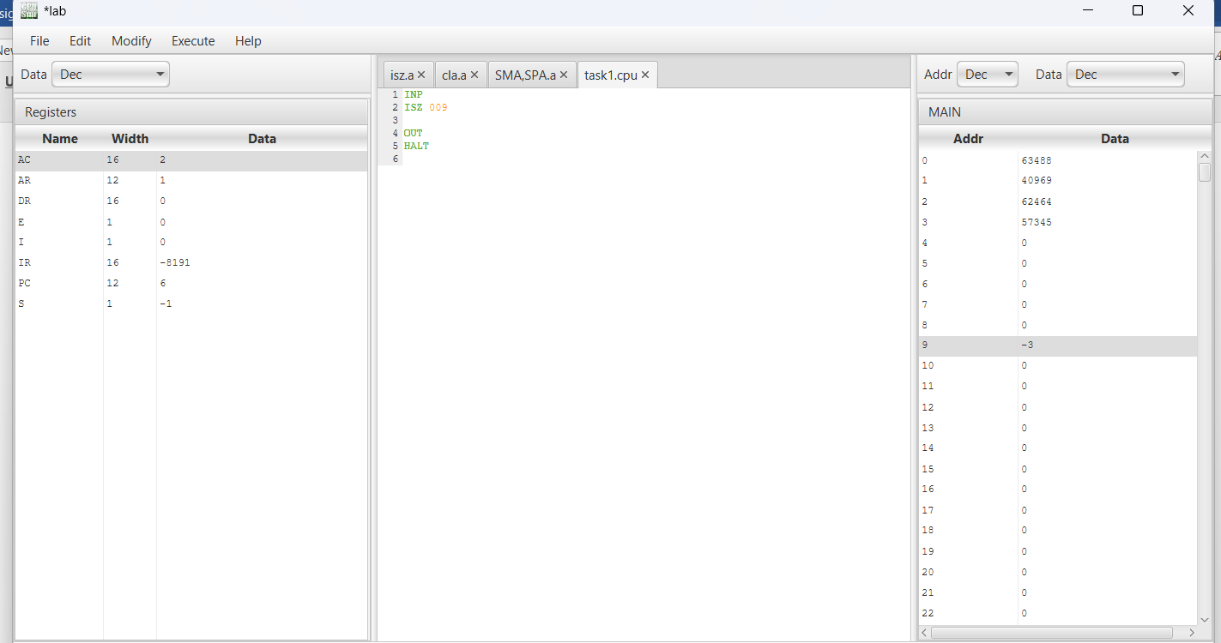

Output:

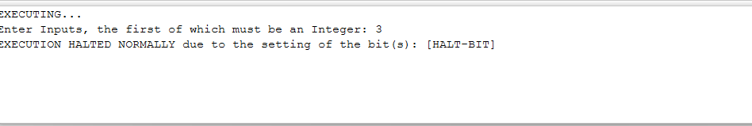

**Task 2:**

**Show that ISZ doesn’t skip when result ≠ 0.**

INP

ISZ 008

OUT

HALT

Output:

